OSPF L2 HSRP Integrated Lab

In this lab we will combine L2 redundancy with HSRP and OSPF.
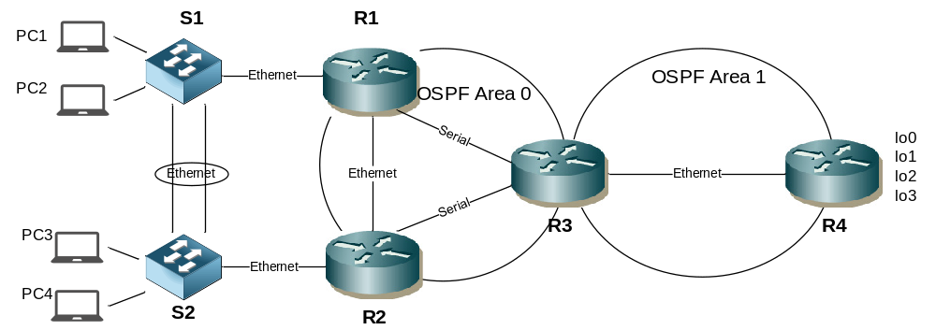

Step 1 - Physical
- Cable up the lab network as per the topology diagram. Note replace Serial with Ethernet links in VIRL
- The routers can be 1841 or 1941 models. Ensure the HWIC-2T (for serial connectivity) is inserted if using packet tracer.
- There is no specification for which end of each serial link should be DCE for serial connections

Step 2 – Configure Layer 2
- Configure S1 & S2 to use Rapid PVST+ spanning tree
spanning-tree mode rapid-pvst

- Create 2 new VLANs on S1 &2 as follows
VLAN ID | VLAN NAME
11 | operations
22 | sales

vlan 11
name operations
vlan 22
name sales

- Configure S1 as the root bridge for both vlans
spanning-tree vlan 11 root primary
spanning-tree vlan 22 root primary

- Configure etherchannel using LACP for the ethernet links between S1 and S2
NOTE – etherchannel needs to configured in a specific order. Configure all the commands under the member physical interfaces, configure channel-group command last. The port-channel interface will be created and inherit the physical interface config.
- Ensure LACP will actively try to negotiate an etherchannel
- Configure the etherchannel as a Trunk that will only carry VLANs 1,11 & 22
- Ensure the trunk is non negotiable
interface range g0/1 – 2
switchport trunk encapsulation dot1q
switchport mode trunk
switchport trunk allowed vlan 1,11,22
switchport nonegotiate
channel-group 1 mode active

- Change the etherchannel loadbalancing to use destination MAC address
port-channel load-balance dst-mac

- Configure PC1 & PC3 user ports in VLAN 11
switchport mode access
switchport access vlan 11

- Configire PC2 & PC4 user ports in VLAN 22
switchport mode access
switchport access vlan 22

- Ensure all user ports will transition to forwarding immediately.
spanning-tree port-fast

- Ensure all user ports will shutdown if any BPDUs are received on that port.
spanning-tree bpdu-guard enable

Step 3 – Inter VLAN Routing
- Configure inter VLAN routing between R1 & S1 and R2 & S2
- Ensure both routers can route traffic to both VLANs 11 & 22
- Configure R1 and R2 LAN addressing as follows
R1 LAN – VLAN 11 | 192.168.11.1/24
R1 LAN – VLAN 22 | 192.168.22.1/24
R2 LAN – VLAN 11 | 192.168.11.2/24
R2 LAN – VLAN 22 | 192.168.22.2/24

S1 example
interface g0/5
switchport mode trunk

R1 example
interface g0/1.11
encapsulation dot1q 11
ip address 192.168.11.1 255.255.255.0
interface g0/1.22
encapsulation dot1q 22
ip address 192.168.22.1 255.255.255.0
interface g0/1
no shut

S2 example
interface g0/5
switchport mode trunk

R2 example
interface g0/1.11
encapsulation dot1q 11
ip address 192.168.11.2 255.255.255.0
interface g0/1.22
encapsulation dot1q 22
ip address 192.168.22.2 255.255.255.0
interface g0/1
no shut

Step 4 – HSRP
- Configure an HSRP standby group on R1 and R3 for both VLANs as per the following table

Group | VIP | Priority R1 | Priority R2
For VLAN 11 | 192.168.11.3/24 | 105 | 100 (default)
For VLAN 22 | 192.168.22.3/24 | 100 (default) | 105

- Ensure the routers can preemptively take control if they have a higher priority
- Ensure that HSRP tracks the state of the serial interface on R1 and R2 and will decrement the standby priority by 10 (default) if it goes down

Vlan 11 example
R1
interface g0/1.11
standby 1 ip 192.168.11.3
standby 1 priority 105
standby 1 track serial0/0/0
standby 1 preempt

R2
interface g0/1.11
standby 1 ip 192.168.11.3
standby 1 track serial0/0/0
standby 1 preempt

Step 5 – Configure PCs (note – use an IOSv node in VIRL to simulate end PC, be aware of memory limitations. It may not be possible to have 4 devices)
- Configure PC IP addresses, mask and default gateway as per the router LAN network and VLAN information above.
- You can choose the IP address to assign to each PC
- Test that each PC can ping its default gateway and that PCs from different VLANs can ping each other

Step 6 – Configure Router interfaces
- Configure the correct end of the serial links with clocking (not required in VIRL)
- Configure router WAN IP addresses as per the table and activate the links

R1 – R2 Ethernet | 172.16.12.0/30
R1 – R3 Serial | 172.16.13.0/30
R2 – R3 Serial | 172.16.23.0/30
R3 – R4 Ethernet | 172.16.34.0/30

- Test each link

Step 7 – Configure OSPF
- Configure OSPF router IDs in the format of x.x.x.x where x = the router number
- Ensure that OSPF can calculate costs for gigabit links less than 100mb
- Ensure R1 is elected DR for the multi access LAN segment between R1 and R2
- Ensure R3 is elected DR for the multi access LAN segment between R3 and R4
- Activate OSPF on router interfaces for the correct Areas as per the table

R1 – R2 Ethernet | Area 0
R1 – R3 Serial | Area 0
R2 – R3 Serial | Area 0
R3 – R4 Serial | Area 1

- Configure Area 1 as a stub area
- Configure MD5 interface authentication between R3 & R4 (password = cisco)
- Advertise R1 & R2 links to S1 & S2 as OSPF internal routes but do not send or receive OSPF hello or LSA packets over these links
R1 Example

router ospf 1
router-id 1.1.1.1
auto-cost reference-bandwidth 1000
network 172.16.12.0 0.0.0.3 area 0
network 172.16.13.0 0.0.0.3 area 0
network 192.168.11.0 0.0.0.255 area 0
network 192.168.22.0 0.0.0.255 area 0
passive-interface g0/1.11
passive-interface g0/1.22

interface g0/2
ip ospf priority 10 *note default is 1, highest wins

R2 Example

router ospf 1
router-id 2.2.2.2
auto-cost reference-bandwidth 1000
network 172.16.12.0 0.0.0.3 area 0
network 172.16.23.0 0.0.0.3 area 0
network 192.168.11.0 0.0.0.255 area 0
network 192.168.22.0 0.0.0.255 area 0
passive-interface g0/1.11
passive-interface g0/1.22

R3 Example

router ospf 1
router-id 3.3.3.3
auto-cost reference-bandwidth 1000
network 172.16.13.0 0.0.0.3 area 0
network 172.16.23.0 0.0.0.3 area 0
network 172.16.34.0 0.0.0.3 area 1
area 1 stub

interface g0/1
ip ospf priority 10 *note default is 1, highest wins
ip ospf authentication message-digest
ip ospf message-digest-key 1 md5 cisco

R4 Example

router ospf 1
router-id 4.4.4.4
auto-cost reference-bandwidth 1000
network 172.16.34.0 0.0.0.3 area 1
area 1 stub

interface g0/1
ip ospf authentication message-digest
ip ospf message-digest-key 1 md5 cisco

Step 8 – Redistribution and summarisation
- Configure the following loopback interfaces on R4

lo0 | 100.4.4.1/24
lo1 | 100.4.1.4/24
lo2 | 100.4.2.4/24
lo3 | 100.4.3.4/24

interface lo0
ip address 100.4.4.1 255.255.255.0
interface lo1
ip address 100.4.1.4 255.255.255.0
interface lo2
ip address 100.4.2.4 255.255.255.0
interface lo3
ip address 100.4.3.4 255.255.255.0

- Advertise the loopback networks into OSPF as internal routes
router ospf 1
network 100.4.4.1 0.0.0.0 area 1
network 100.4.1.4 0.0.0.0 area 1
network 100.4.2.4 0.0.0.0 area 1
network 100.4.3.4 0.0.0.0 area 1

- Confirm the routes are present in R3s route table
- Summarise the the 4 loopback networks from area 1 into a single route on the ABR
R3
router ospf 1
area 1 range 100.4.0.0 255.255.248.0

- Confirm summary is present on R1 and R2

- Configure the following static routes on R4

R4(config)#ip route 200.2.0.0 255.255.255.0 null 0
R4(config)#ip route 200.2.1.0 255.255.255.0 null 0

- Redistribute the statics into OSPF with a static cost of 25
R4
router ospf 1
redistribute static metric 25 subnets

- Confirm the routes are present in R3s route table

Step 9 – Testing
- Test that each PC can ping each loopback interface on R4
- Confirm the path taken from each PC to the lo0 on R4 and back again

Challenge
- How could ensure the loopback networks are advertised into OSPF as /24 and not /32 ?
interface loopback1
ip ospf network point-to-point

